|  |  |  |  |
| --- | --- | --- | --- |
| **F:\Learning bugs\Foundation Subjects\Dolly the Fly - Science.jpgLyng Primary School Knowledge Organiser** | | | |
| **Topic:** | **Science**  **Living Things and their Habitats** | Year 6 | Autumn 1 |

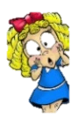

|  |  |
| --- | --- |
| **What Step On and Goldilocks words will I use?** | |
| **Spelling** | **Definition** |
| Amphibian | A vertebrate that lays jelly-coated eggs, is cold-blooded, has moist skin and breathes with either lungs, gills or through their skin. |
| Binomial system | A system used to give living things a two-part Latin name. |
| Bird | A vertebrate that has feathers, lays hard shelled eggs, breathes with lungs and is warm-blooded. |
| Characteristic | A feature that allows something to be sorted into a group. |
| Classification key | A diagram used to sort organisms using their similarities and differences. |
| Classify | To group something based on similarities. |
| Cold-blooded | Animals that rely on external sources, like the Sun, to control their body temperature. |
| Fish | A vertebrate that breathes with gills, lays soft eggs in water, has wet scales and is cold-blooded. |
| Life processes | The seven processes a living thing performs (movement, respiration, sensitivity, growth, reproduction, excretion, nutrition). |
| Linnaean system | A system created by Carl Linnaeus to classify living things according to shared characteristics. |
| Mammal | A vertebrate that has fur, produces milk, breathes with lungs and is warm-blooded. |
| Organism | A living thing. |
| Reptile | A vertebrate that breathes with lungs, lays leathery eggs, has dry scales and is cold-blooded (e.g. snake). |
| Vertebrate | An animal with a back bone. |

**Notable scientists**

Carl Linnaeus

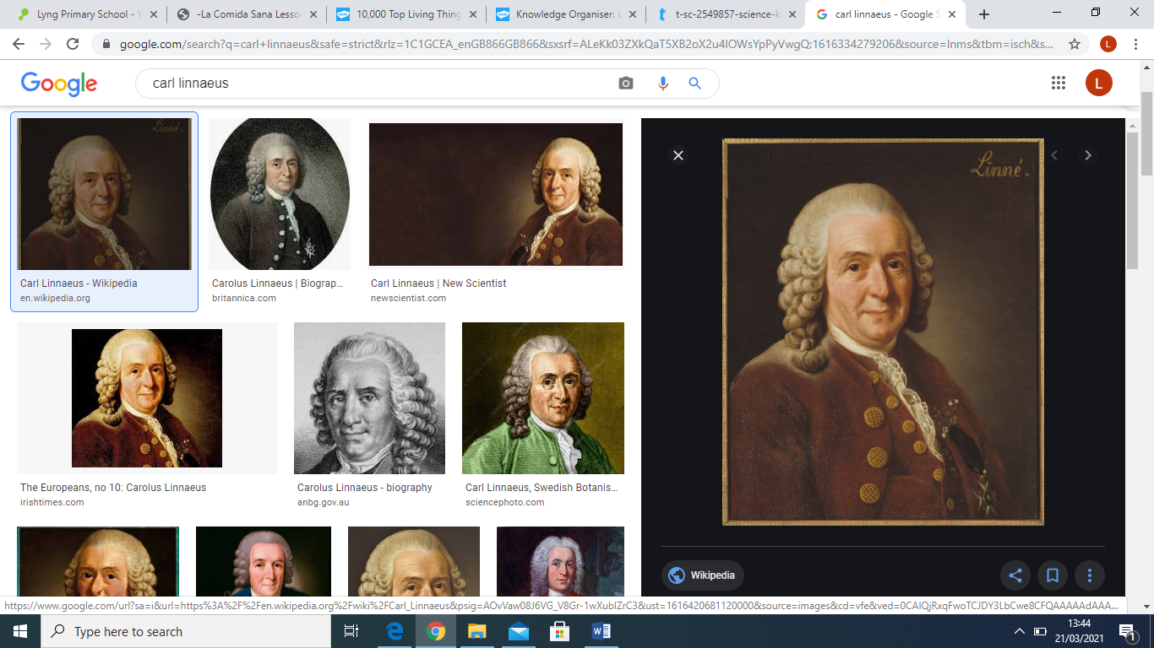

**What should I already know?**Children will build on their learning about grouping living things in Year 4 by looking at the classification system in more detail. They will be introduced to the idea that broad groupings, such as microorganisms, plants and animals can be subdivided into smaller categories.

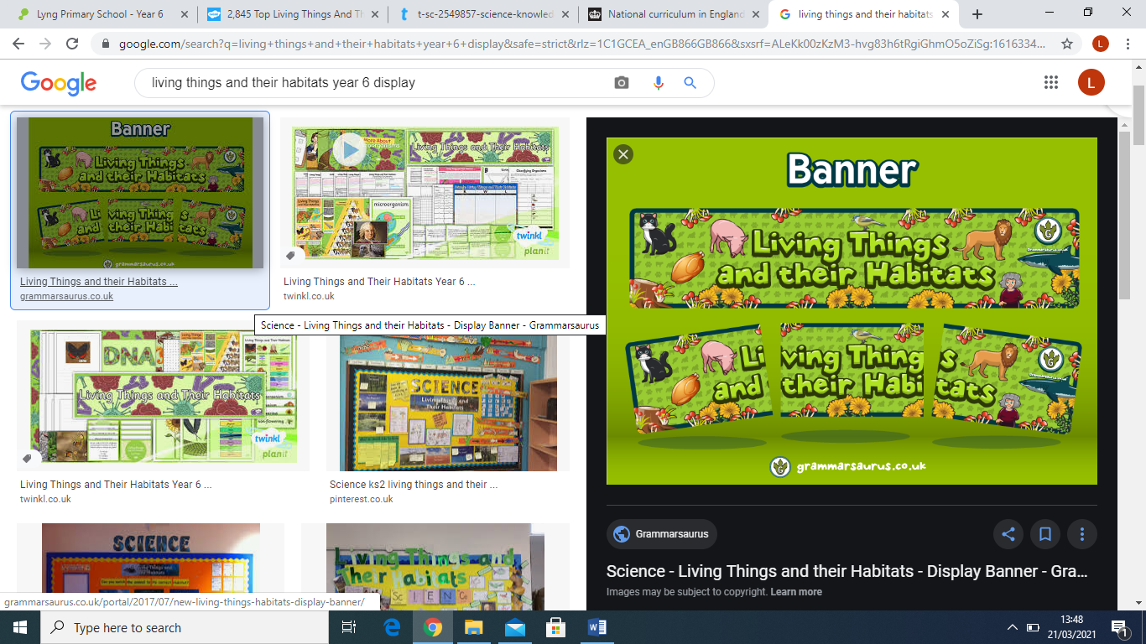

|  |
| --- |
| **Enquiry Questions** |
| * How are organisms classified? * How can we classify cold-blooded vertebrates? * How can we classify warm-blooded vertebrates? * How do you classify invertebrates? * How is the plant kingdom organised? * How can se describe and classify micro-organisms? |

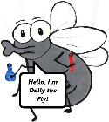

**What will I know by the end of the unit?**

|  |
| --- |
| Children will… |
| …describe how living things are classified into broad groups according to common observable characteristics and based on similarities and differences, including micro-organisms, plants and animals. By studying our key scientist (Carl Linnaeus) children will have a wider understanding of the classification system used to classify living things. |
| …give reasons for classifying plants and animals based on specific characteristics.  Children will practise classifying animals by analysing a range of animals and based on their  characteristics/appearance, they will place them into sub-categories. |

|  |  |  |  |
| --- | --- | --- | --- |
| **F:\Learning bugs\Foundation Subjects\Dolly the Fly - Science.jpgLyng Primary School Knowledge Organiser** | | | |
| **Topic:** | **Science**  **Living Things and their Habitats** | Year 6 | Autumn 1 |

|  |  |
| --- | --- |
| 1. Who invented a system for classifying living things that is still used today? | |
| **S** |  |
| **E** |  |

|  |  |  |
| --- | --- | --- |
| 5. Complete the Linnean System using the word bank below: | **S** | **E** |
| Put these in their correct order on the Linnaean System:    Family  Kingdom  Species  Domain  Order  Phylum  Genus  Class |  |  |

|  |  |  |
| --- | --- | --- |
| 1. What tool cannot be used to classify living things? | **S** | **E** |
| 1. Skeleton key. |  |  |
| 1. Branching key. |  |  |
| 1. Number key. |  |  |
| 1. Classification key. |  |  |

|  |  |  |
| --- | --- | --- |
| 1. What vertebrate group usually gives birth to live young? | **S** | **E** |
| 1. Amphibians |  |  |
| 1. Mammals |  |  |
| 1. Fish |  |  |

|  |  |  |
| --- | --- | --- |
| 1. Which plants produce spores? | **S** | **E** |
| 1. Mosses |  |  |
| 1. Flowering plants. |  |  |
| 1. Mosses and ferns. |  |  |
| 1. Conifers and flowering plants. |  |  |

|  |  |  |
| --- | --- | --- |
| 1. Which cold-blooded vertebrate does not have scales? | **S** | **E** |
| 1. Reptile |  |  |
| 1. Amphibian |  |  |
| 1. Fish. |  |  |
| 1. None – they all have scales. |  |  |